A Case Study
In this section, we introduce a case study to demonstrate the feasibility of our approach. In the study, an EFM of the video playing software domain is collaboratively constructed by stakeholders from different backgrounds. For simplicity, only three stakeholders are involved. Two of them are frequent users (U1 and U2), and the other one (Programmer P) has experience in developing video playing software.
U1 is the first contributor, as shown in Table IV.
- The EFM at the Beginning (Part)
Elements in the EFM | Votes of Stakeholders
Elements in the EFM | U1
Features
Play Control (F1), Play/Pause (F2), Stop (F3) | ○_{C}
Relationships
(F2, F3) refines F1 | ○_{C}
○_{C}: YES votes initiated when creating (PR-CV).
After that, another user U2 joins and makes some changes on the EFM, as Table V shows.
- The EFM After U2 Joins (Part)
Elements in the EFM | Votes of Stakeholders
Elements in the EFM | U1 | U2
Features
Play Control (F1), Play/Pause (F2), Stop (F3) | ○_{C} | ○
Basic Control (F4), Advanced Control (F5), Repeat (F6), Jump (F7);  Streaming Media (F8), Online Video Clip (F9), Online TV (F10) |  | ○_{C}
Relationships
(F2, F3) refines F1 | ○_{C} | X
(F2, F3) refines F4; (F6, F7) refines F5; (F4, F5) refines F1; (F9, F10) refines F8 |  | ○_{C}
○: YES votes submitted by voting operations.
X: NO votes submitted by voting operations.
Now conflicts emerge from U1’s working view, i.e. conflicting refinements (F2, F3) refines F1/F4. (When U2 created (F2, F3) refines F4, he denied the refinement created by U1 as well, otherwise he would get a conflict.)
After reconsidering the refinements, U1 resolves the conflict by voting no on (F2, F3) refines F1. In addition, the Advanced Control created by U2 inspires U1 to add more features relating to it. However, U1 opposes the existence of Online TV because he always uses specialized software provided by special service providers like BBC, to watch online TV programs. Therefore he believes it belongs to a different domain. Table VI shows the changes made by U1.
- The EFM Updated by U1 (Part)
Elements in the EFM | Votes of Stakeholders
Elements in the EFM | U1 | U2
Features
Play Control (F1), Play/Pause (F2), Stop (F3) | ○_{C} | ○
Basic Control (F4), Advanced Control (F5), Repeat (F6), Jump (F7);  Streaming Media (F8), Online Video Clip (F9) | ○_{P} | ○_{C}
Online TV (F10) | X | ○_{C}
Slow (F11), Fast (F12) | ○_{C}
Relationships
(F2, F3) refines F1 | X | X
(F2, F3) refines F4; (F6, F7) refines F5; (F4, F5) refines F1 | ○ | ○_{C}
F10 refines F8 | X_{p} | ○_{C}
F9 refines F8 | ○ | ○_{C}
(F11, F12) refines F5 | ○_{C}
○_{P}: YES votes propagated according to PR-1 to PR-6.
X_{p}: NO votes propagated according to PR-1 to PR-6.
Although it is just a very small part of the EFM, it still reflects important characteristics of our approach:
- Divergence Tolerance: (Temporary) divergence on the domain can be tolerated and coexist in the EFM for further negotiation. Some divergence eventually transforms into consensus (e.g. (F2, F3) refines F1/F4); some might not and is considered as an indicator of domain variability (e.g. Online TV).
- Consensus Facilitation: By reserving and highlighting divergence and conflicts in working views, stakeholders are guided to focus on these elements, which can help achievement of consensus.
In addition, the quality of the feature model is improved when more stakeholders join the construction. This can be demonstrated through the construction of video format/codec related features, before and after the programmer P joins.
Before the programmer joins, U1 and U2 have created some features about the video file formats. However, they confused video format with codec due to lack of technical expertise, as Table VII shows. (A video format can store data of different codec, e.g. MP4 is a video format which can hold data of the codec MPEG-4 ASP, MPEG-4 AVC or VC-1.)
- Format/Codec Before P Joins (Part)
Elements in the EFM | Votes of Stakeholders
Elements in the EFM | U1 | U2
Features
Video Format (F1), AVI (F2), MP4 (F3) | ○_{C} | ○
MKV (F4), WMV (F5) |  | ○_{C}
Names (Aliases)
F3: MPEG-4 (confuse MP4 with MPEG-4) |  | ○_{C}
Relationships
(F2, F3) refines F1 | ○_{C}
(F4, F5) refines F1 |  | ○_{C}
After the programmer joins, he clears up the confusion of format and codec, and adds constraints between them, thus the quality of the EFM is improved. (See Table VIII.)
- Format/Codec After P Joins (Part)
Elements in the EFM | Votes of Stakeholders
Elements in the EFM | U1 | U2 | P
Features
Video Format (F1), AVI (F2), MP4 (F3) | ○_{C} | ○ | ○_{P}
MKV (F4), WMV (F5) |  | ○_{C} | ○_{P}
Video Codec (F6), MPEG-4 AVC (F7), MPEG-4 ASP (F8) |  |  | ○_{C}
Names (Aliases)
F3: MPEG-4 |  | ○_{C} | X
F4: Matroska; F7: H.264 |  |  | ○_{C}
Relationships
(F2, F3) refines F1 | ○_{C} |  | ○
F4 refines F1 |  | ○_{C} | ○
F5 refines F1 |  | ○_{C} | X
(F7, F8) refines F6 |  |  | ○_{C}
F6 mutual-requires F1 (formats and codec must work together to deliver video data) |  |  | ○_{C}
During the construction, users tend to focus on service-level features and contribute little to constraints. In contrast, the programmer is able to add more implementation-level features and explore the constraints between existing features. Therefore the EFM becomes more comprehensive and useful with the help of collaboration between stakeholders.
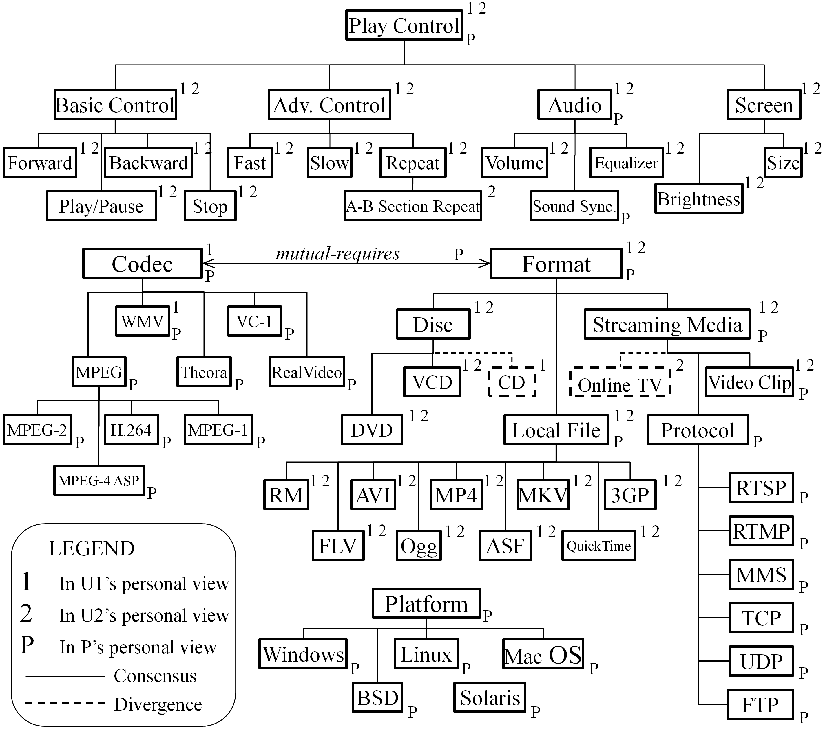
Fig. 5 shows the EFM, in which the consensus and divergence, as well as features in different personal views are marked. We can see that the personal views depict different perspectives of the domain. For example, when talking about Streaming Media, there’s no difference between online TV and online video clip for the programmer, only Protocol matters. In contrast, users care about the difference between TV programs and video clips.
- The EFM of video playing software domain.

